**Software Testing Assignment**

**Advanced Selenium**

# Module – 7 (Selenium Webdriver)

**Demo Websites To Practice selenium Webdriver**

|  |  |
| --- | --- |
|  | **Website**  **List** |
| • | [1 List of Websites to Practice Selenium](https://www.techbeamers.com/websites-to-practice-selenium-webdriver-online/#list-ofwebsites-to-practice-selenium)    o 1.1 1. https://phptravels.com/demo/ o [1.2 2. http://thedemosite.co.uk/](https://www.techbeamers.com/websites-to-practice-selenium-webdriver-online/#2httpthedemositecouk) o [1.3 3. http://newtours.demoaut.com/](https://www.techbeamers.com/websites-to-practice-selenium-webdriver-online/#3httpnewtoursdemoautcom) o [1.4 4. http://the-internet.herokuapp.com/](https://www.techbeamers.com/websites-to-practice-selenium-webdriver-online/#4httpthe-internetherokuappcom) o [1.5 5. http://automationpractice.com/index.php](https://www.techbeamers.com/websites-to-practice-selenium-webdriver-online/#5httpautomationpracticecomindexphp) o [1.6 6. http://book.theautomatedtester.co.uk/](https://www.techbeamers.com/websites-to-practice-selenium-webdriver-online/#6httpbooktheautomatedtestercouk) o [1.7 7. https://s1.demo.opensourcecms.com/wordpress/](https://www.techbeamers.com/websites-to-practice-selenium-webdriver-online/#7httpss1demoopensourcecmscomwordpress) |

* W.A.J.Script for Locating links by linkText() and partialLinkText()

|  |
| --- |
| package com.webdriver;  import org.openqa.selenium.By;  import org.openqa.selenium.WebDriver;  import org.openqa.selenium.chrome.ChromeDriver;  public class Ele_PartialLinkText  {  public static void main(String[] args) throws InterruptedException  {  System.setProperty("webdriver.chrome.driver", "E:\\TOPS\\SELENIUM\\chromedriver-win32\\chromedriver.exe");  WebDriver driver=new ChromeDriver();  driver.get("file:///E:\\TOPS\\Project_WS\\Selenium_Morning\\src\\com\\html\\Index.html");  Thread.sleep(3000);    driver.findElement(By.partialLinkText("Here")).click();  Thread.sleep(3000);  driver.navigate().back();  Thread.sleep(3000);  driver.findElement(By.xpath("/html/body/a[2]")).click();  Thread.sleep(3000);  driver.findElement(By.linkText("Forgotten password?")).click();  driver.navigate().back();  driver.navigate().back();      driver.close();  }  } |

* W.A.J.Script for Selecting multiple items in a drop dropdown

|  |
| --- |
| package com.webdriver;  import org.openqa.selenium.By;  import org.openqa.selenium.WebDriver;  import org.openqa.selenium.chrome.ChromeDriver;  import org.openqa.selenium.support.ui.Select;  public class Ele_Select  {  public static void main(String[] args) throws InterruptedException  {  System.setProperty("webdriver.chrome.driver", "E:\\TOPS\\SELENIUM\\chromedriver-win32\\chromedriver.exe");  WebDriver driver=new ChromeDriver();  driver.get("https://demo.guru99.com/test/newtours/register.php");  Thread.sleep(3000);    Select s1=new Select(driver.findElement(By.name("country")));  s1.selectByIndex(5);  Thread.sleep(3000);  s1.selectByValue("AUSTRIA");  Thread.sleep(3000);  s1.selectByVisibleText("BAHAMAS");  Thread.sleep(3000);    for(int i=0;i<=50;i++)  {  s1.selectByIndex(i);  Thread.sleep(3000);  }  driver.close();    }  } |

* W.A.J. script to use different methods to manage the windows-alerts and pop ups.

|  |
| --- |
| package com.webdriver;  import org.openqa.selenium.Alert;  import org.openqa.selenium.By;  import org.openqa.selenium.WebDriver;  import org.openqa.selenium.chrome.ChromeDriver;  public class AlertDemo  {  public static void main(String[] args) throws InterruptedException  {  System.setProperty("webdriver.chrome.driver", "E:\\TOPS\\SELENIUM\\chromedriver-win32\\chromedriver.exe");  WebDriver driver=new ChromeDriver();  driver.get("https://demo.guru99.com/test/delete_customer.php");  Thread.sleep(2000);    driver.findElement(By.name("cusid")).sendKeys("9514");;  Thread.sleep(2000);  driver.findElement(By.name("submit")).click();  Thread.sleep(3000);    Alert a1=driver.switchTo().alert();  System.out.println("Alert 1 message is.. "+a1.getText());  //a1.dismiss();  a1.accept();    Thread.sleep(2000);    Alert a2=driver.switchTo().alert();  System.out.println("Alert 2 message is.. "+a2.getText());  //a1.dismiss();  a2.accept();      Thread.sleep(2000);  driver.close();  }  } |

* W.A.J.script to register your self in Gmail.

|  |
| --- |
| **package** com.assign2;  **import** org.openqa.selenium.By;  **import** org.openqa.selenium.WebDriver;  **import** org.openqa.selenium.chrome.ChromeDriver;  **import** org.openqa.selenium.support.ui.Select;  **public** **class** Gmail_Register  {  **public** **static** **void** main(String[] args) **throws** InterruptedException  {  System.*setProperty*("webdriver.chrome.driver", "E:\\TOPS\\SELENIUM\\chromedriver-win32\\chromedriver.exe");  WebDriver driver=**new** ChromeDriver();  driver.get("https://www.google.com/gmail/about/");  Thread.*sleep*(2000);    driver.findElement(By.*linkText*("Create an account")).click();  Thread.*sleep*(2000);  driver.findElement(By.*id*("firstName")).sendKeys("Hetal");  Thread.*sleep*(2000);  driver.findElement(By.*id*("lastName")).sendKeys("Shah");  Thread.*sleep*(2000);  driver.findElement(By.*className*("VfPpkd-vQzf8d")).click();  Thread.*sleep*(2000);    Select s1=**new** Select(driver.findElement(By.*id*("month")));  s1.selectByValue("11");  Thread.*sleep*(2000);  driver.findElement(By.*xpath*("//*[@id=\"day\"]")).sendKeys("14");  Thread.*sleep*(2000);  driver.findElement(By.*xpath*("//*[@id=\"year\"]")).sendKeys("1995");  Thread.*sleep*(2000);  Select s2=**new** Select(driver.findElement(By.*id*("gender")));  s2.selectByVisibleText("Female");  Thread.*sleep*(2000);  driver.findElement(By.*className*("VfPpkd-vQzf8d")).click();  Thread.*sleep*(2000);  driver.findElement(By.*name*("Username")).sendKeys("hetal1995shah");  Thread.*sleep*(2000);  driver.findElement(By.*className*("VfPpkd-vQzf8d")).click();  Thread.*sleep*(2000);    driver.findElement(By.*name*("Passwd")).sendKeys("Het@14shah");  Thread.*sleep*(2000);  driver.findElement(By.*name*("PasswdAgain")).sendKeys("Het@14shah");  Thread.*sleep*(2000);  driver.findElement(By.*className*("VfPpkd-vQzf8d")).click();  Thread.*sleep*(2000);    driver.close();    }  } |

* W.A.J. Script To perform the radio button to select one by one in loop <http://demo.guru99.com/test/radio.html>

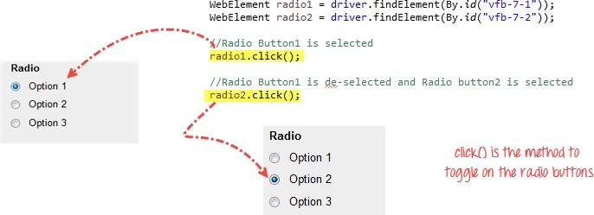

A)

|  |
| --- |
| package com.webdriver;  import org.openqa.selenium.By;  import org.openqa.selenium.By.ByCssSelector;  import org.openqa.selenium.WebDriver;  import org.openqa.selenium.chrome.ChromeDriver;  public class Ele_RadioButton  {  public static void main(String[] args) throws InterruptedException  {  System.setProperty("webdriver.chrome.driver", "E:\\TOPS\\SELENIUM\\chromedriver-win32\\chromedriver.exe");  WebDriver driver=new ChromeDriver();  driver.get("https://demo.guru99.com/test/radio.html");  Thread.sleep(2000);    driver.findElement(By.cssSelector("input[value='Option 1']")).click();  Thread.sleep(2000);  driver.findElement(By.cssSelector("input[value='Option 2']")).click();  Thread.sleep(2000);  driver.findElement(By.cssSelector("input[value='Option 3']")).click();  Thread.sleep(2000);    for(int i=1;i<=3;i++)  {  driver.findElement(By.cssSelector("input[value='Option 1']")).click();  Thread.sleep(2000);  }  driver.close();  } |

* W.A.J. script To write the script for image of logo facebook using xpath.

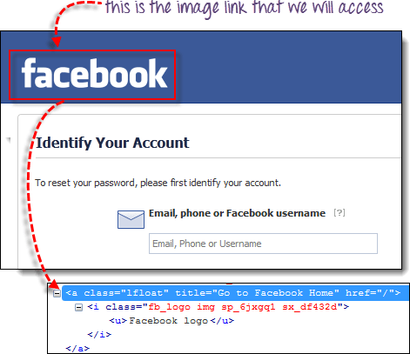

* W.A.J.Script To write a script for drop down.

<http://demo.guru99.com/test/newtours/register.php>

A)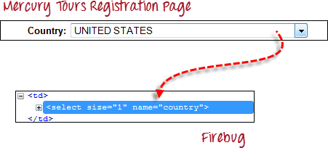

|  |
| --- |
| package com.webdriver;  import org.openqa.selenium.By;  import org.openqa.selenium.WebDriver;  import org.openqa.selenium.chrome.ChromeDriver;  import org.openqa.selenium.support.ui.Select;  public class Ele_Select  {  public static void main(String[] args) throws InterruptedException  {  System.setProperty("webdriver.chrome.driver", "E:\\TOPS\\SELENIUM\\chromedriver-win32\\chromedriver.exe");  WebDriver driver=new ChromeDriver();  driver.get("https://demo.guru99.com/test/newtours/register.php");  Thread.sleep(3000);    Select s1=new Select(driver.findElement(By.name("country")));  s1.selectByIndex(5);  Thread.sleep(3000);  s1.selectByValue("AUSTRIA");  Thread.sleep(3000);  s1.selectByVisibleText("BAHAMAS");  Thread.sleep(3000);    for(int i=0;i<=50;i++)  {  s1.selectByIndex(i);  Thread.sleep(3000);  }  driver.close();    }  } |

* W.A.J.Script To use Mouse and Keyboard event using Action class 1.Mouse Hover Event

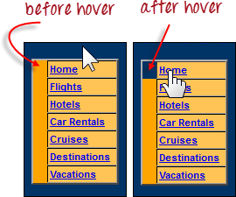

A)

|  |
| --- |
| package com.webdriver;  import org.openqa.selenium.By;  import org.openqa.selenium.WebDriver;  import org.openqa.selenium.WebElement;  import org.openqa.selenium.chrome.ChromeDriver;  import org.openqa.selenium.interactions.Action;  import org.openqa.selenium.interactions.Actions;  public class Ele_MouseEvent  {  public static void main(String[] args) throws InterruptedException  {  System.setProperty("webdriver.chrome.driver", "E:\\TOPS\\SELENIUM\\chromedriver-win32\\chromedriver.exe");  WebDriver driver=new ChromeDriver();  driver.get("https://demo.guru99.com/test/newtours/register.php");  Thread.sleep(2000);    WebElement home=driver.findElement(By.linkText("Home"));  WebElement hotels=driver.findElement(By.linkText("Hotels"));  WebElement flights=driver.findElement(By.linkText("Flights"));    Actions actions=new Actions(driver);  Action a1=actions.moveToElement(home).build();  a1.perform();  Thread.sleep(2000);  Action a2=actions.moveToElement(hotels).build();  a2.perform();  Thread.sleep(2000);  Action a3=actions.moveToElement(flights).build();  a3.perform();  Thread.sleep(2000);    driver.close();    }  } |

2. Keyboard event

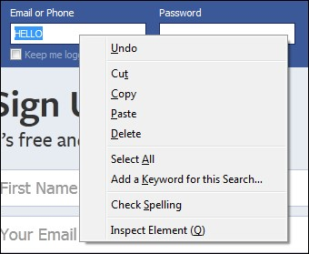

A)

|  |
| --- |
| package com.webdriver;  import org.openqa.selenium.By;  import org.openqa.selenium.Keys;  import org.openqa.selenium.WebDriver;  import org.openqa.selenium.WebElement;  import org.openqa.selenium.chrome.ChromeDriver;  import org.openqa.selenium.interactions.Action;  import org.openqa.selenium.interactions.Actions;  public class Ele_KeyboardEvent  {  public static void main(String[] args) throws InterruptedException  {  System.setProperty("webdriver.chrome.driver", "E:\\TOPS\\SELENIUM\\chromedriver-win32\\chromedriver.exe");  WebDriver driver=new ChromeDriver();  driver.get("https://www.facebook.com/");  Thread.sleep(2000);    WebElement email=driver.findElement(By.id("email"));    Actions actions=new Actions(driver);  Action a1=actions.moveToElement(email).click()  .keyDown(email, Keys.SHIFT)  .sendKeys(email, "Hetal")  .keyUp(email, Keys.SHIFT)  .doubleClick()  .contextClick()  .build();  a1.perform();  Thread.sleep(2000);  } |

* W.A.J. Script How to handled Alert in selenium

["http://demo.guru99.com/test/delete_customer.php "](http://demo.guru99.com/test/delete_customer.php)

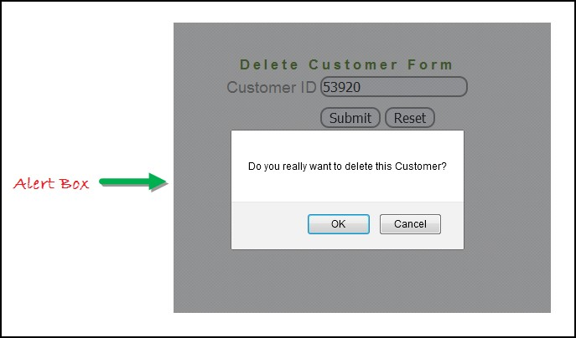

A)

|  |
| --- |
| package com.webdriver;  import org.openqa.selenium.Alert;  import org.openqa.selenium.By;  import org.openqa.selenium.WebDriver;  import org.openqa.selenium.chrome.ChromeDriver;  public class AlertDemo  {  public static void main(String[] args) throws InterruptedException  {  System.setProperty("webdriver.chrome.driver", "E:\\TOPS\\SELENIUM\\chromedriver-win32\\chromedriver.exe");  WebDriver driver=new ChromeDriver();  driver.get("https://demo.guru99.com/test/delete_customer.php");  Thread.sleep(2000);    driver.findElement(By.name("cusid")).sendKeys("9514");;  Thread.sleep(2000);  driver.findElement(By.name("submit")).click();  Thread.sleep(3000);    Alert a1=driver.switchTo().alert();  System.out.println("Alert 1 message is.. "+a1.getText());  //a1.dismiss();  a1.accept();    Thread.sleep(2000);    Alert a2=driver.switchTo().alert();  System.out.println("Alert 2 message is.. "+a2.getText());  //a1.dismiss();  a2.accept();      Thread.sleep(2000);  driver.close();  }  } |

* W.A.J. Script To find the total hyperlink from this web page <http://demo.guru99.com/test/web-table-element.php>

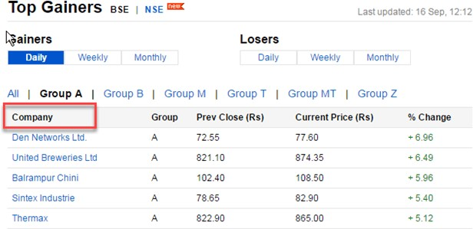

A)

|  |
| --- |
| package com.webdriver;  import java.util.List;  import org.openqa.selenium.By;  import org.openqa.selenium.WebDriver;  import org.openqa.selenium.WebElement;  import org.openqa.selenium.chrome.ChromeDriver;  public class Ele_Table2  {  public static void main(String[] args) throws InterruptedException  {  System.setProperty("webdriver.chrome.driver", "E:\\TOPS\\SELENIUM\\chromedriver-win32\\chromedriver.exe");  WebDriver driver=new ChromeDriver();  driver.get("https://demo.guru99.com/test/web-table-element.php");  Thread.sleep(2000);    //String msg=driver.findElement(By.xpath("//*[@id="leftcontainer"]/table/thead/tr/th[1]")).getText();  //System.out.println(msg);    //String msg1=driver.findElement(By.xpath("//*[@id="leftcontainer"]/table/tbody/tr[1]/td[1]/a")).getText();  //System.out.println(msg1);    List<WebElement> th=driver.findElements(By.xpath("//*[@id=\"leftcontainer\"]/table/thead/tr/th"));  System.out.println("Th size is.. "+th.size());    List<WebElement> tr=driver.findElements(By.xpath("//*[@id=\"leftcontainer\"]/table/tbody/tr"));  System.out.println("Tr size is.. "+tr.size());    for(int i=1;i<=th.size();i++)  {  String msg=driver.findElement(By.xpath("//*[@id=\"leftcontainer\"]/table/thead/tr/th["+i+"]")).getText();  System.out.print(msg+" ");  }  System.out.println();  for(int i=1;i<=tr.size();i++)  {  for(int j=1;j<=th.size();j++)  {  String value=driver.findElement(By.xpath("//*[@id=\"leftcontainer\"]/table/tbody/tr["+i+"]/td["+j+"]")).getText();  System.out.println(value+" ");  }  System.out.println();  }    }  } |

* W.a.junit program to handled Assert class with all method to check its pass or fail

A)

|  |
| --- |
| package com.unit1;  import static org.junit.Assert.assertArrayEquals;  import static org.junit.Assert.assertEquals;  import static org.junit.Assert.assertFalse;  import static org.junit.Assert.assertNotNull;  import static org.junit.Assert.assertNotSame;  import static org.junit.Assert.assertNull;  import static org.junit.Assert.assertSame;  import static org.junit.Assert.assertTrue;  import static org.junit.Assert.fail;  import org.junit.Test;  public class Junt_Assertion  {  @Test  public void test()  {  int a=10, b=20;  String s1=null,s2="Hetal",s3="Hetal";  int[] x= {1,2,3,4,5};  int[] y= {1,2,3,4,5};  assertTrue(a<b);  assertFalse(a>b);  assertNull(s1);  assertNotNull(s2);  assertEquals(s2,s3);  assertSame(s2,s3);  assertNotSame(s2,s3);  assertArrayEquals(x, y);  fail("self failed");  }  } |

* W.a. junit program to perform test with webdriver to login process of facebook

A)

|  |
| --- |
| package com.unit2;  import org.junit.After;  import org.junit.Before;  import org.junit.Test;  import org.openqa.selenium.By;  import org.openqa.selenium.WebDriver;  import org.openqa.selenium.chrome.ChromeDriver;  public class Junit_Webdriver  {  WebDriver driver=null;    @Before  public void beforeLogin() throws InterruptedException  {  System.setProperty("webdriver.chrome.driver", "E:\\TOPS\\SELENIUM\\chromedriver-win32\\chromedriver.exe");  driver=new ChromeDriver();  driver.get("https://www.facebook.com/");  Thread.sleep(2000);  }  @Test  public void loginTest() throws InterruptedException  {  driver.findElement(By.id("email")).sendKeys("8200610810");  Thread.sleep(1000);  driver.findElement(By.id("pass")).sendKeys("het@123");  Thread.sleep(1000);  driver.findElement(By.name("login")).click();  Thread.sleep(2000);  }  @After  public void afterLogin() throws InterruptedException  {  Thread.sleep(2000);  System.out.println("Bye Bye...");  driver.close();  }    } |

* W.a. junit program to check gmail login using with

@before,@after,@Test

A)

|  |
| --- |
| package com.unit2;  import org.junit.After;  import org.junit.Before;  import org.junit.Test;  import org.openqa.selenium.By;  import org.openqa.selenium.WebDriver;  import org.openqa.selenium.chrome.ChromeDriver;  public class Junit_Webdriver  {  WebDriver driver=null;    @Before  public void beforeLogin() throws InterruptedException  {  System.setProperty("webdriver.chrome.driver", "E:\\TOPS\\SELENIUM\\chromedriver-win32\\chromedriver.exe");  driver=new ChromeDriver();  driver.get("https://www.google.com/gmail/about/");  Thread.sleep(2000);  }  @Test  public void loginTest() throws InterruptedException  {  driver.findElement(By.xpath("/html/body/header/div/div/div/a[2]")).click();  Thread.sleep(1000);  driver.findElement(By.id("identifierId")).sendKeys("hetalshah1495");  Thread.sleep(1000);  driver.findElement(By.className("VfPpkd-vQzf8d")).click();  Thread.sleep(1000);  driver.findElement(By.name("Passwd")).sendKeys("het@123");  Thread.sleep(1000);  driver.findElement(By.className("VfPpkd-vQzf8d")).click();  Thread.sleep(1000);  }  @After  public void afterLogin() throws InterruptedException  {  Thread.sleep(2000);  System.out.println("Bye Bye...");  driver.close();  }  } |

* W.a. junit program to use parameterized demo with multiple parameter of Facebook login in junit.

A)

|  |
| --- |
| **package** com.ng3;  **import** **static** org.testng.Assert.*fail*;  **import** org.openqa.selenium.By;  **import** org.openqa.selenium.WebDriver;  **import** org.openqa.selenium.chrome.ChromeDriver;  **import** org.testng.annotations.AfterTest;  **import** org.testng.annotations.BeforeTest;  **import** org.testng.annotations.Parameters;  **import** org.testng.annotations.Test;  **public** **class** Testng_ParameterDemo  {  WebDriver driver=**null**;  @BeforeTest  **public** **void** beforeLogin() **throws** InterruptedException  {  System.*setProperty*("webdriver.chrome.driver", "E:\\TOPS\\SELENIUM\\chromedriver-win32\\chromedriver.exe");  driver=**new** ChromeDriver();  driver.get("https://www.facebook.com/");  Thread.*sleep*(2000);  }    @Test  @Parameters({"email","password"})  **public** **void** Test(String email,String password) **throws** InterruptedException  {  driver.findElement(By.*cssSelector*("input[type=\"text\"]")).sendKeys(email);  Thread.*sleep*(2000);  driver.findElement(By.*cssSelector*("input[type=\"password\"]")).sendKeys(password);  Thread.*sleep*(2000);  driver.findElement(By.*cssSelector*("input.42ft _4jy0 _6lth._4jy6 _4jy1.selected _51sy")).click();  Thread.*sleep*(2000);    }  @AfterTest  **public** **void** afterLogin() **throws** InterruptedException  {  Thread.*sleep*(2000);  System.***out***.println("Bye Bye....");  driver.close();  }  } |

* W.a. TestNG program to perform test with webdriver to login process of facebook
* W.a. TestNG program to check gmail login using with

@beforetest,@aftertest,@Test

* W.a. TestNG program to use parameterized demo with multiple parameter of Facebook login with TestNG.

A)

|  |
| --- |
| **package** com.ng3;  **import** **static** org.testng.Assert.*fail*;  **import** org.openqa.selenium.By;  **import** org.openqa.selenium.WebDriver;  **import** org.openqa.selenium.chrome.ChromeDriver;  **import** org.testng.annotations.AfterTest;  **import** org.testng.annotations.BeforeTest;  **import** org.testng.annotations.Parameters;  **import** org.testng.annotations.Test;  **public** **class** Testng_ParameterDemo  {  WebDriver driver=**null**;  @BeforeTest  **public** **void** beforeLogin() **throws** InterruptedException  {  System.*setProperty*("webdriver.chrome.driver", "E:\\TOPS\\SELENIUM\\chromedriver-win32\\chromedriver.exe");  driver=**new** ChromeDriver();  driver.get("https://www.facebook.com/");  Thread.*sleep*(2000);  }    @Test  @Parameters({"email","password"})  **public** **void** Test(String email,String password) **throws** InterruptedException  {  driver.findElement(By.*cssSelector*("input[type=\"text\"]")).sendKeys(email);  Thread.*sleep*(2000);  driver.findElement(By.*cssSelector*("input[type=\"password\"]")).sendKeys(password);  Thread.*sleep*(2000);  driver.findElement(By.*cssSelector*("input.42ft _4jy0 _6lth._4jy6 _4jy1.selected _51sy")).click();  Thread.*sleep*(2000);    }  @AfterTest  **public** **void** afterLogin() **throws** InterruptedException  {  Thread.*sleep*(2000);  System.***out***.println("Bye Bye....");  driver.close();  }  } |

* W.a. TestNG program to create group with testing.xml file • w.a. TestNG program to create dataprovider.

A)

|  |
| --- |
| **package** com.ng3;  **import** **static** org.testng.Assert.*fail*;  **import** org.openqa.selenium.By;  **import** org.openqa.selenium.WebDriver;  **import** org.openqa.selenium.chrome.ChromeDriver;  **import** org.testng.annotations.AfterTest;  **import** org.testng.annotations.BeforeMethod;  **import** org.testng.annotations.DataProvider;  **import** org.testng.annotations.Test;  **public** **class** DataProviderDemo  {  @DataProvider(name = "Hetal")  **public** Object[][] input()  {  **return** **new** Object[][] {{"standard_user","secret_sauce"},{"problem_user","secret_sauce"},{"hetal_sauce","secret_sauce"}};  }  WebDriver driver=**null**;  @BeforeMethod  **public** **void** beforeLogin() **throws** InterruptedException  {  System.*setProperty*("webdriver.chrome.driver", "E:\\TOPS\\SELENIUM\\chromedriver-win32\\chromedriver.exe");  driver=**new** ChromeDriver();  driver.get("https://www.saucedemo.com/");  Thread.*sleep*(2000);  }  @Test(dataProvider = "Hetal")  **public** **void** test(String username,String password) **throws** InterruptedException  {  driver.findElement(By.*cssSelector*("input[type=\"text\"]")).sendKeys(username);  Thread.*sleep*(2000);  driver.findElement(By.*cssSelector*("input[data-test=\"password\"]")).sendKeys(password);  Thread.*sleep*(2000);  driver.findElement(By.*cssSelector*("input.submit-button.btn_action")).click();  Thread.*sleep*(2000);  **if**(driver.getCurrentUrl().equals("https://www.saucedemo.com/inventory.html"))  {  System.***out***.println("Your Login Test has been Passed");  }  **else**  {  System.***out***.println("Your Login Test has been Failed");  *fail*("invalid username or password");  }  }  @AfterTest  **public** **void** afterLogin() **throws** InterruptedException  {    Thread.*sleep*(2000);  System.***out***.println("Bye Bye....");  driver.close();  }  } |